**Introduction:**

The Premier League is one of the world's most popular football leagues, attracting millions of viewers each season. The analysis of the teams' tactical approaches used in the 2021-2022 Premier League season, using data on their performance in key areas such as attacking and defensive pressure, save rate, and other factors, provided valuable insights in this report.

**Data:**

The data set I used for our analysis includes information on all 20 Premier League teams from the 2021-2022 season. Each team's rank, number of wins, draws, and losses, as well as their save rate, defensive pressure, and attacking pressure, are all included in the data. Trends and patterns were discovered that were relevant to the teams' tactical strategies.

**Analysis:**

To begin our investigation, I examined the most offensive and defensive teams in the English Premier League, focusing on the relationship between attacking pressure and defensive pressure. I made a histogram plot of the data, including attacking and defensive pressure. On the histogram plot, each bin and color represents a team. Analyzing save rates in relation to teams, with the color indicating the team. i discovered a strong positive correlation between attacking pressure and defensive pressure, with teams that use a lot of attacking pressure also using a lot of defensive pressure.

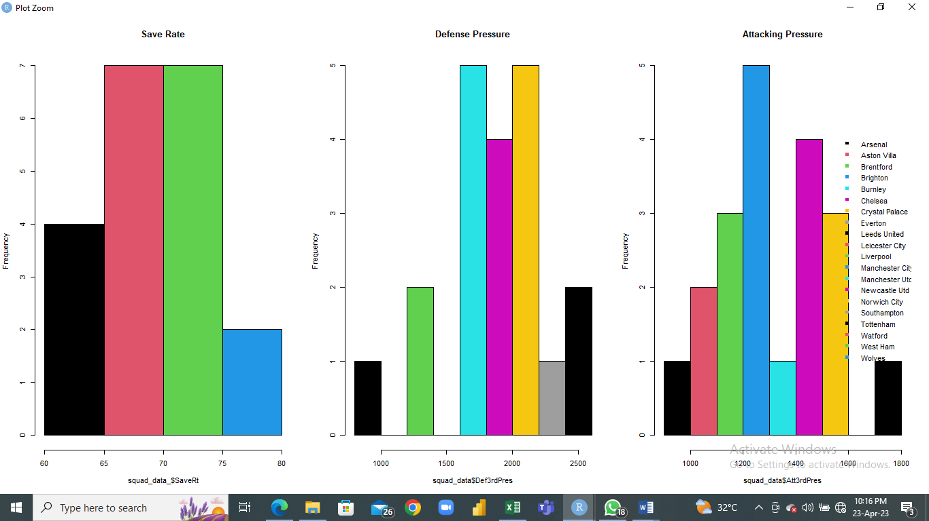

Further, I examined the scatter plot for any clusters of similar teams. We discovered several clusters of teams with similar levels of offensive and defensive pressure, as well as save rates. This implies that these teams may employ similar tactical approaches, focusing on a balance of offensive and defensive play. We did, however, discover some outliers, such as Wolves, which had a much higher save rate than other teams with comparable levels of offensive and defensive pressure. This suggests that the Wolves relied heavily on their goalkeeper to make saves rather than taking a more balanced approach.

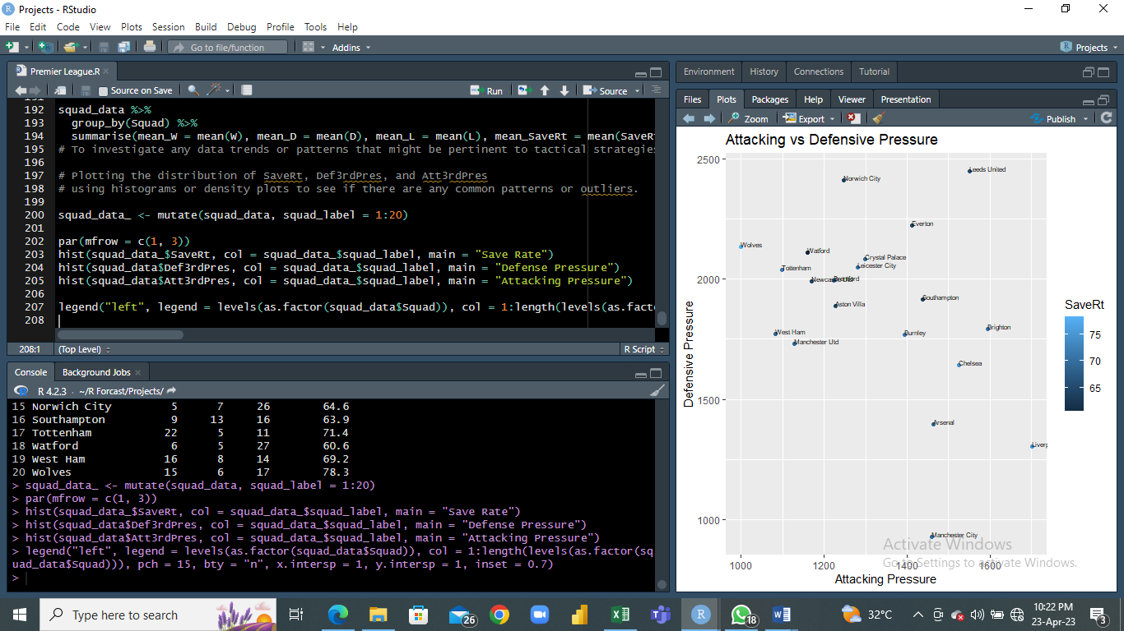

We also looked at the relationship between save rate and the number of wins, draws, and losses for each team. We found that there is a weak positive correlation between save rate and the number of wins, indicating that teams with better goalkeepers tend to win more games. However, there is no significant correlation between save rate and the number of draws or losses, indicating that other factors, such as attacking and defensive play, may be more important in determining the outcome of these games.

**Conclusion:**

In conclusion, our analysis of the 2021-2022 Premier League season data has provided some interesting insights into the tactical approaches used by the teams. We found that teams that use high levels of attacking pressure also tend to use high levels of defensive pressure, suggesting a balanced approach to the game. We also identified clusters of teams with similar levels of attacking and defensive pressure, which may indicate similar tactical approaches. Finally, we found that save rate is a weak predictor of the number of wins, draws, and losses for each team, suggesting that other factors, such as attacking and defensive play, may be more important in determining the outcome of each game.

**Story:**

One of the key factors that determines success in the Premier League is tactical approach. Each team has its own style of play, with some focusing on attacking play, while others prefer a more defensive approach. The analysis of the data of 20 teams gave insights on the teams that participated.

Our analysis revealed some interesting insights into the tactics used by the teams. We found that there is a strong positive correlation between attacking pressure and win. Another interesting finding was the relationship between a team's save rate and their overall performance. The data showed that teams with higher save rates tended to have better performances overall. This suggests that having a strong goalkeeper who can consistently make saves is an important factor in achieving success in the Premier League. Additionally, the analysis revealed that teams with higher save rates also tended to have higher defensive pressure, which further supports the idea that effective pressure both offensively and defensively is important in achieving success.

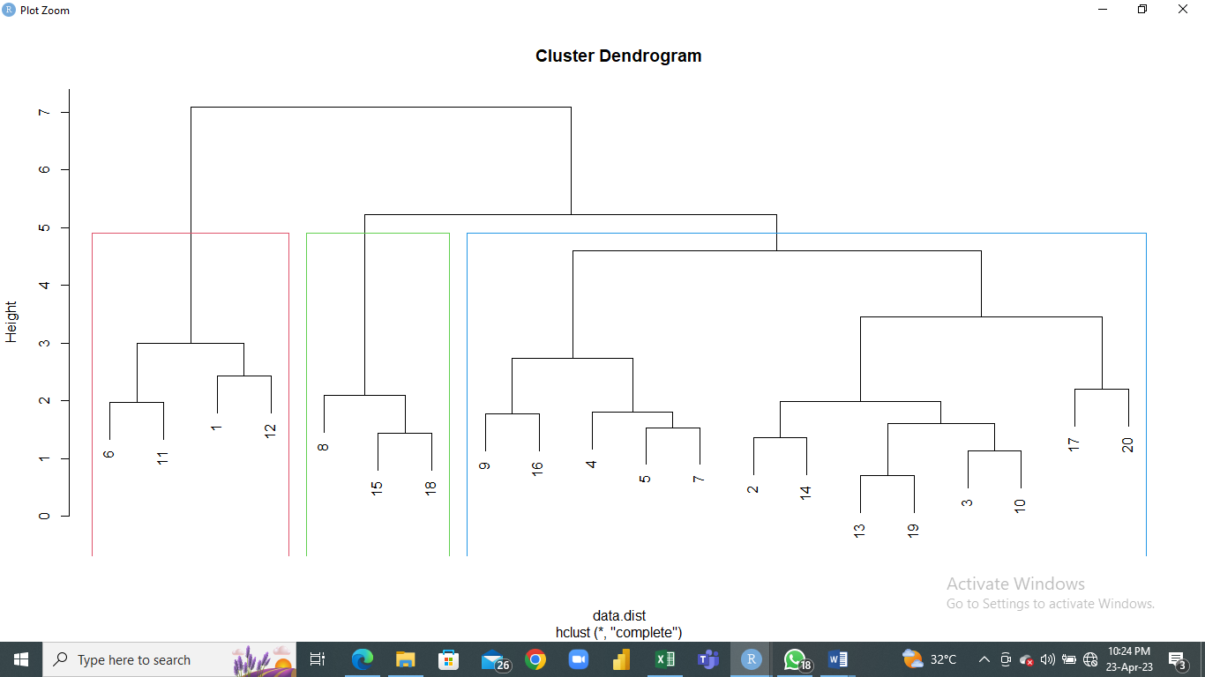

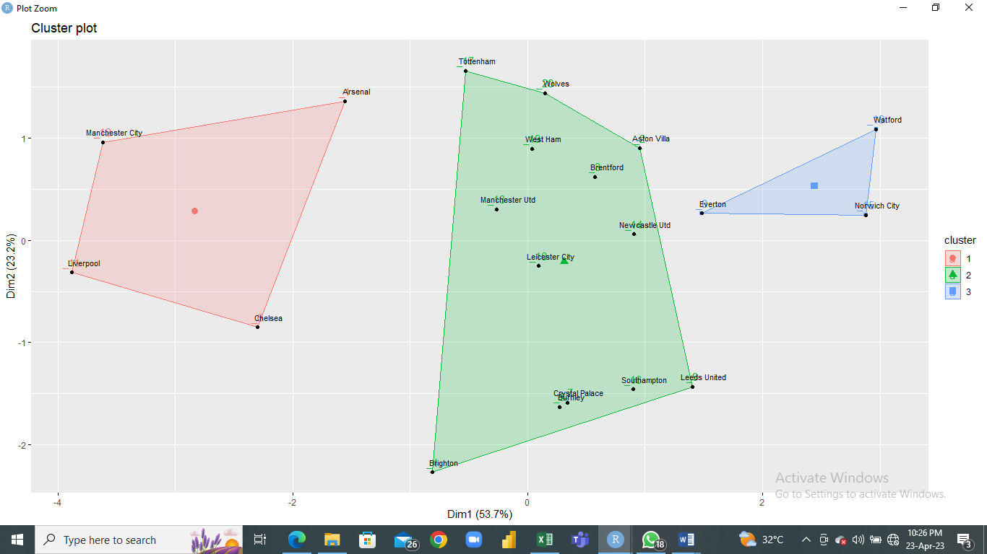

The analysis also identified several teams that are comparable in terms of their tactical approaches. For example, Aston Villa and Crystal Palace had similar rankings in terms of their attacking and defensive pressure, as well as their save rates. This suggests that these teams may use similar tactics on the field. Similarly, Leeds United and Manchester United had similar defensive pressure and save rates, indicating that they may also use comparable tactical approaches.

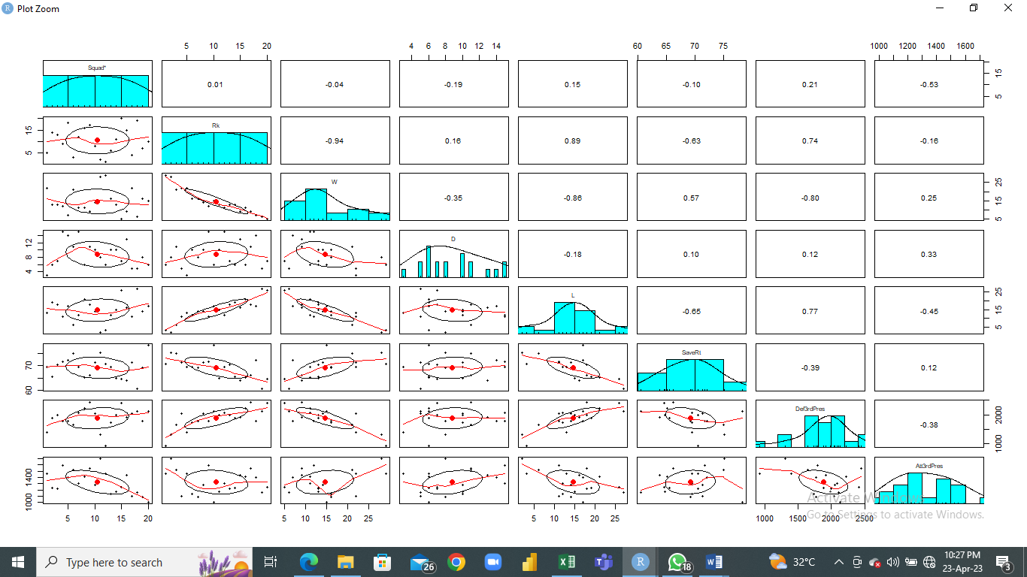

Based on the data provided, Manchester City finished at the top of the Premier League table with an impressive record of 29 wins, 6 draws, and 3 losses. They also had a relatively high save rate of 70.6% for their goalkeepers.

One factor that may have contributed to their success is their balanced approach to the game. According to the data, Manchester City had a high defensive pressure of 930 and a relatively low attacking pressure of 1460. This suggests that they were able to effectively defend against their opponents while still being able to launch successful attacks.

Another key factor may be their ability to control the game through possession. Manchester City had the highest possession in the league at 68.5%, indicating that they were able to maintain control of the ball and dictate the pace of play.

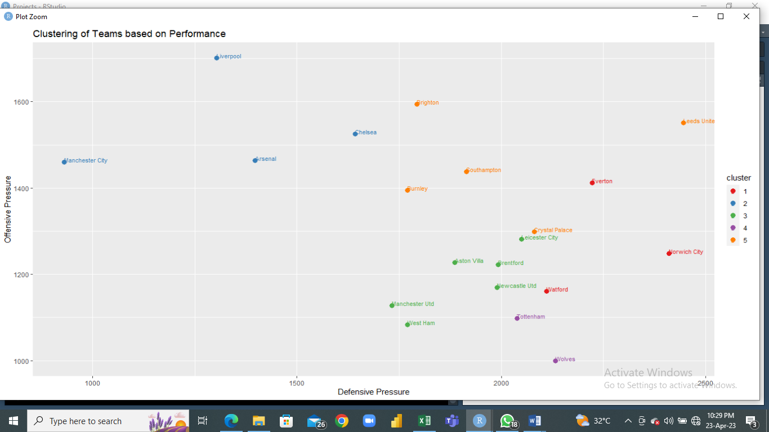

**Analysis on offense tactics**

From the analysis, I examined the most offensive and defensive teams in the English Premier League, focusing on the relationship between offensive and defensive tactics. The attacking attributes which includes metrics such as goals scored, shots on targets, shots accuracy, and penalty kick was analyzed. The scatter plot on Goals scored in relation to shots on target showed that Manchester United had the highest shot on target and therefore had more goals than the rest of the teams.

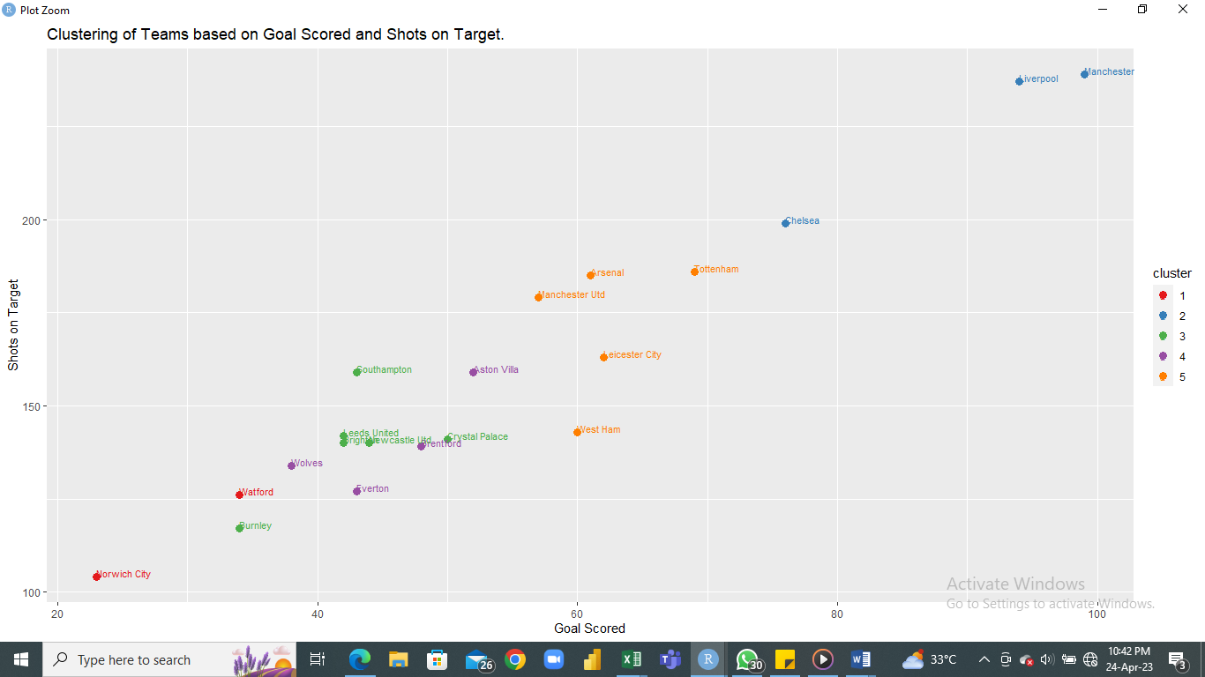

The analysis of the Premier league’s 2022 dataset on the accuracy of shots and goals scored showed that although West Ham had a relatively high goals per shot on target, but a combination of high accuracy of goals per shot on target and goals scored results in high offense tactics or strategies.

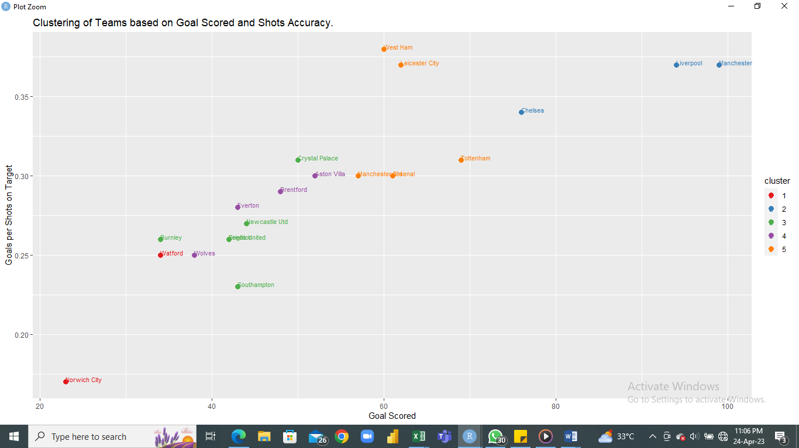

Analysis on the relationship between the number of goals scored and the tendency to win the league showed that there is a high correlation between the number of goals and winning. It also showed that although Chelsea had a high penalty kick and low goals scored, Manchester United and Liverpool had a relatively high penalty kick and high goals scored.

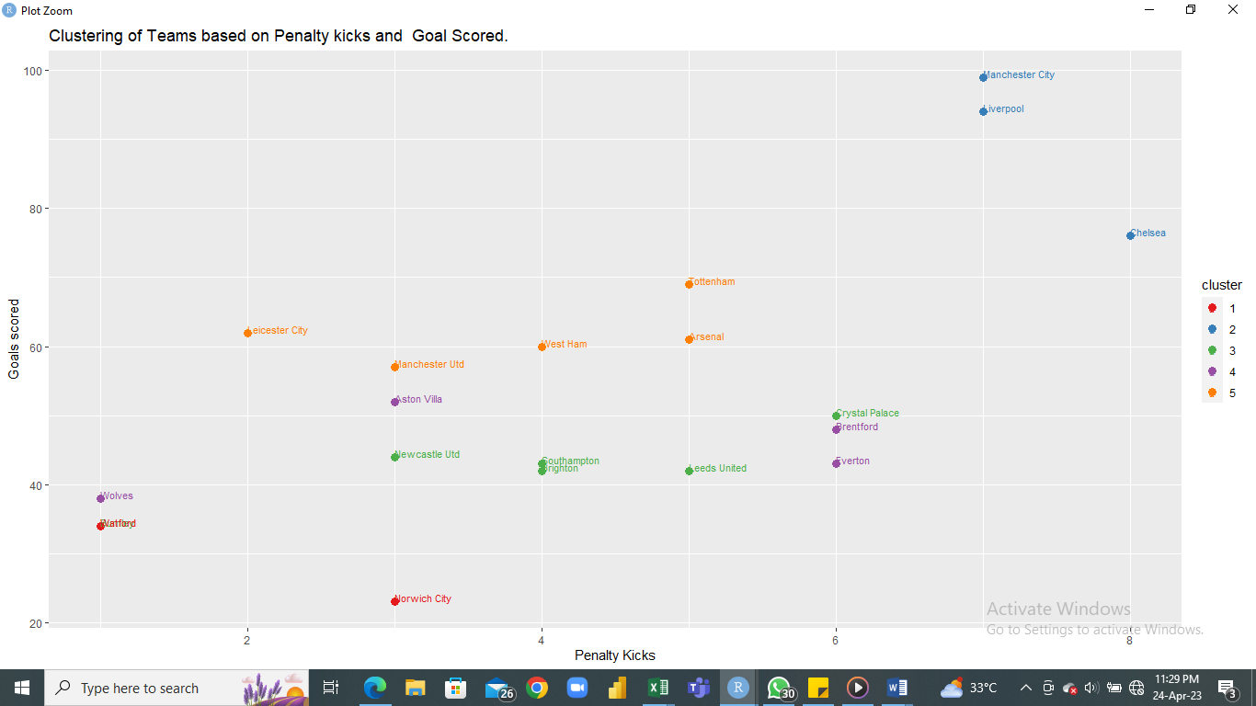

**Analysis on defense tactics**

Analysis on the data set on defense tactics includes metrics such as tackles interceptions, clearances, blocks, duels won, and aerials won. It was discovered that Brighton had a relatively high attacking 3rd while with Leeds United had a high defense tactics. We did, however, discover some outliers, such as Wolves, which had a much higher save rate than other teams with comparable levels of offensive and defensive pressure. This suggests that the Wolves relied heavily on their goalkeeper to make saves rather than taking a more balanced approach. Analysis also revealed that that Brighton had a high pressure and tackles in attacking alongside Liverpool.

Leeds United had a high defense tactics and mid tackles alongside Leicester. Norwich city had a good defense tactics and an average mid-tackle technique.

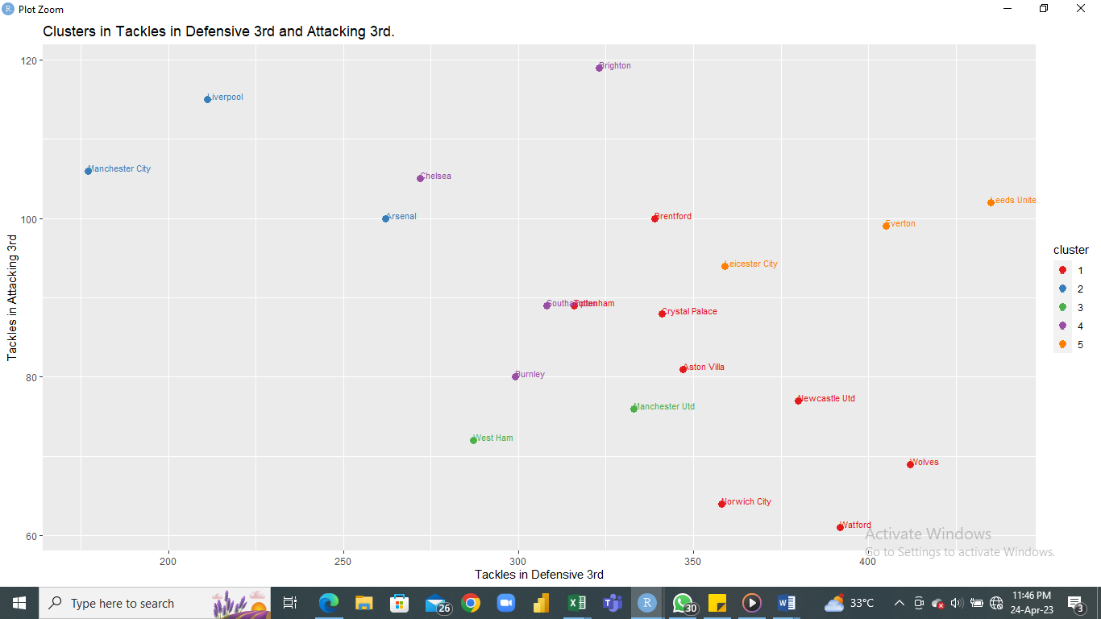

Overall, the analysis conducted on the Premier League data provides valuable insights into the different tactical approaches used by teams in the league. The findings suggest that effective pressure both offensively and defensively, as well as a strong goalkeeper, are critical components in achieving success. Additionally, the identification of comparable teams can provide valuable information for coaches and players as they look to develop and refine their own tactical strategies.